Structured API Overview:
Structured API refers to following 3 core distributed collection APIs:
- DataFrames
- DataSets
- SQL Tables and Views
Need to know few keywords,
Schema:
- Defines the column names and types of a DataFrame.
- You can define schemas manually or read a schema from a data source (often called schema on read).

Columns:
- Columns represent a simple type like an integer or string, a complex type like an array or map, or a null value.
Rows:
- A row represents the record of data.
- Each record in a DataFrame must be of type Row.

Spark Types:
- Spark has a large number of internal type representations.

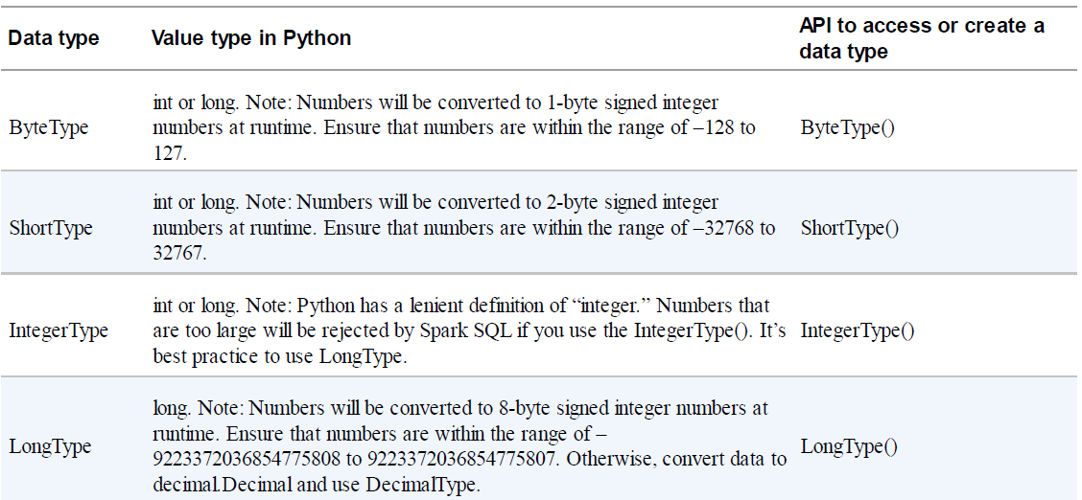

DataFrames:
- DataFrames are (distributed) table-like collections with well-defined rows and columns.
- Each column has type information that must be consistent for every row in the collection.
- When you’re using DataFrames, you’re taking advantage of Spark’s optimized internal format.
- Spark has its own datatypes.
- Internally, Spark uses an engine called Catalyst that maintains its own type information through the planning and processing of work.
- Spark types map directly to the different language APIs that Spark maintains and there exists a lookup table for each of these in Scala, Java, Python, SQL, and R.
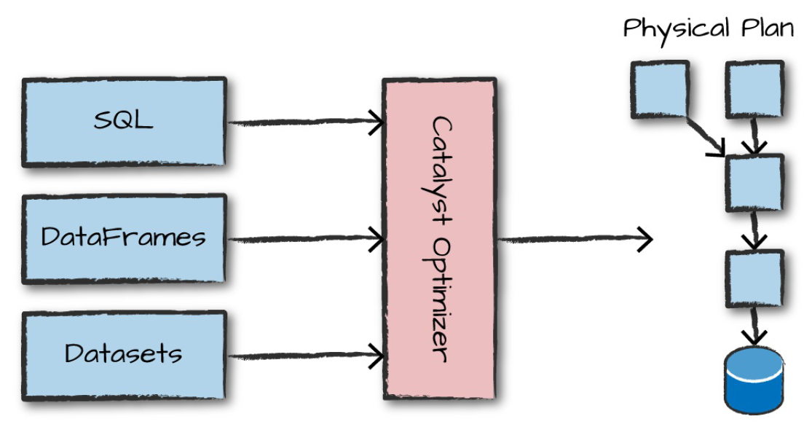

Phase-1: Logical Planning
Takes user code and converts it into a logical plan.
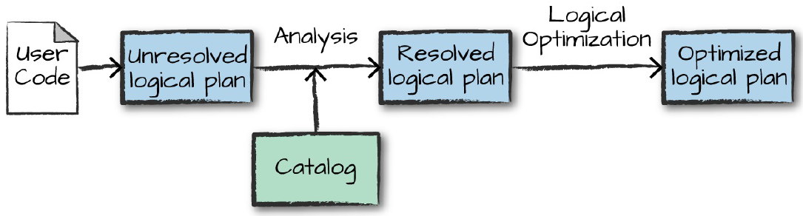

- Spark converts the user code into unresolved logical plan.
- Although your code might be valid, the tables or columns that it refers to might or might not exist.So,Spark uses the catalog, a repository of all table and DataFrame information, to resolve columns and tables in the analyzer.
- If the analyzer can resolve it, the result is passed through the Catalyst Optimizer, a collection of rules that attempt to optimize the logical plan by pushing down predicates or selections.

Phase-2: Physical Planning
- Physical plan, often called a Spark plan, specifies how the logical plan will execute on the cluster.
- Physical planning results in a series of RDDs and transformations.
- Spark generates different physical plans then compares the cost through a cost model and picks one best physical plan.
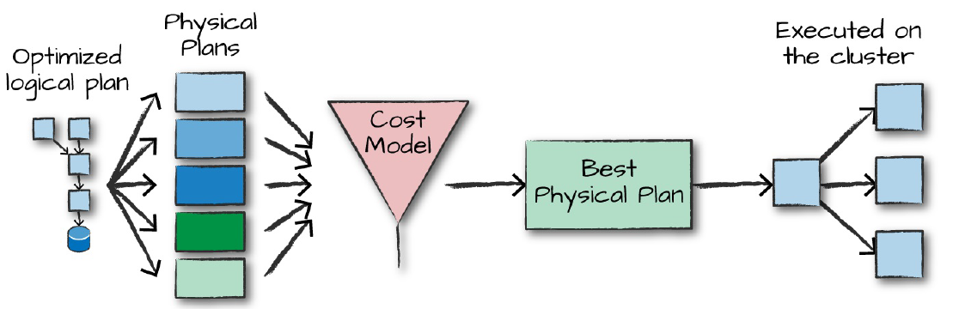

Phase-3: Execution
- Upon selecting the best physical plan, Spark runs all of this code on cluster.

Difference between DataFrames and DataSets?
- In DataFrames, Spark internally maintains the datatypes and only checks whether those types line up to those specified in the schema at runtime.
- DataSets checks the whether types conform to the specification at compile time. Datasets are only available to JVM based languages (i.e. Scala and Java) and not available for Python and R.

